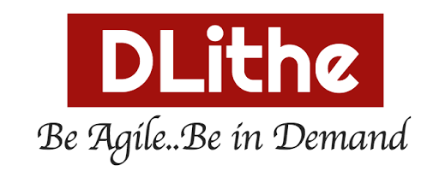

FRONT END DEVELOPMENT INTERNSHIP

Name: Kartik V Naik

Email: [kartiknaikhanehalli@gmail.com](mailto:kartiknaikhanehalli@gmail.com)

GitHub: https://github.com/knaik1302/whether-app

Submitted to,

Mr.Razak Ahmad

Mr.Arun

|  |  |
| --- | --- |
| S.no | Contents |
| 1 | Introduction |
| 2 | About Dlithe |
| 3. | Snap Shot of Project (Whether App) |
| 4. | Thank you |

INDEX

INTRODUCTION

**Front End Development**

We were made aware of the extent of possibilities through Front End Development and how it has made its mark in becoming the most demanding Reactjs out there.

**Internship Overview**

At the beginning of the course, we were provided with information about its history and how it became the most popular. We know of now and then went on with the introduction to some of the flavour it gives for its community and the overwhelming extent of library it has to offer. This course went from the basics to being able to solve intermediate-level customer requirements.

This course explores JavaScript based front-end application development, and in particular the React library. This course will use JavaScript ES6 for developing React application. We also got an introduction to the use of Bootstrap for Bootstrap 5 and Material UI-based responsive UI design and also got introduction about various aspects of React components. You will learn about React router and its use in developing single-page applications.

**Concepts**

Our Mentor made us understand the whole concept by defining its syntax, functionality, and effective usability of the same using some examples.

* Overview of Front End Development
* Software installation
* Html, Css coding
* Java Script Coding
* React coding
* Front End Development
* Introduction about Bootstrap 5 and Material UI
* Introduction about Rest Api (Axios)
* Importance of Customer Experience

**Conclusion**

This Journey has been fun and at the same time knowledgeable. This course has helped me gain fundamental knowledge about Reactjs and on the whole, has taught me how to go forward with solving any kind of customer problems implementing front end development.

ABOUT DLITHE

DLithe is EduTech company located in Bengaluru, serving corporate and academic institutions. The company vision is to build an agile workforce towards Industry needs.

The company has developed software solutions for a client in Healthcare domain. The company also provides technical consultancy in upgrading the platforms (legacy to modern), resource onboarding, competency development services.

The company has 20+ technical consultants in delivering various services of the company.

The company is lead by Arun Rajpurohit and Sridhar Murthy, industry professionals with a rich experience in IT services and product development.

SNAPSHOT OF PROJECT

Whether App project:

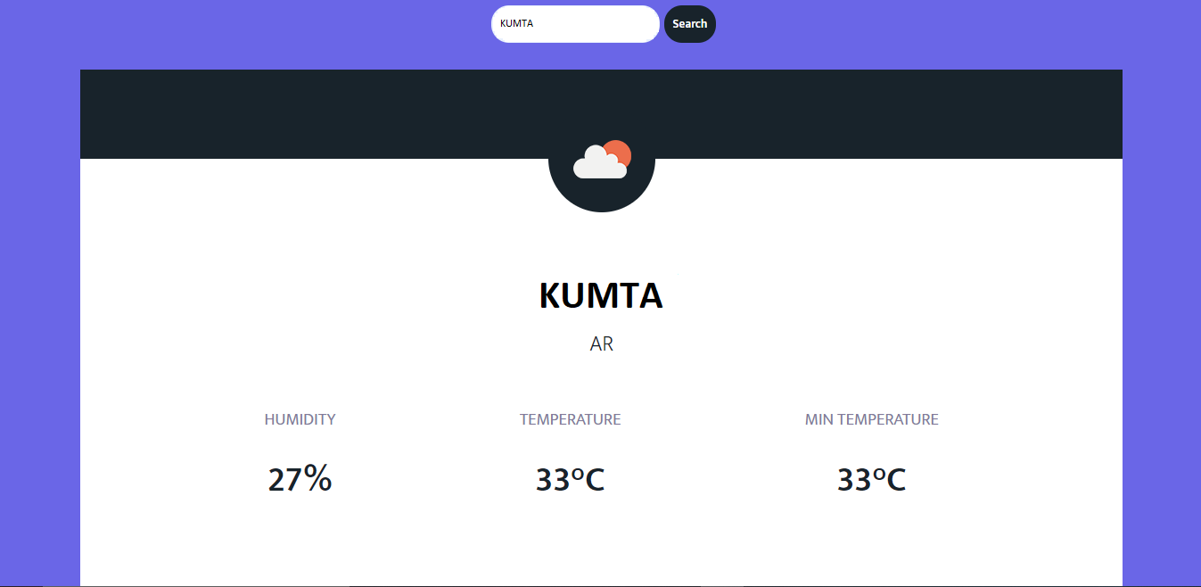

Pic 1.

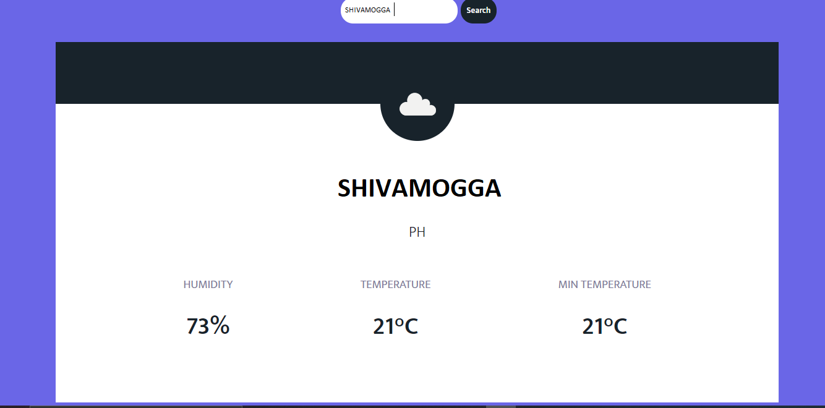

Pic 2.

THANK YOU